H.T No
Regulations:
A18

Sreenidhi Institute of Science and Technology
(An Autonomous Institution)
Code No: 7A714 Date: 05-July-2023 (AN)

B.Tech IV-Year I- Semester External Examination, July - 2023 (Supplementary)
POWER SYSTEM ANALYSIS AND CONTROL (EEE)

Time: 3 Hours Max.Marks:70

Note: a) No additional answer sheets will be provided.
b) All sub-parts of a question must be answered at one place only, otherwise it will not be valued.
c) Missing data can be assumed suitably.

Bloom's Cognitive Levels of Learning (BCLL)

Remember | L1 | Apply | L3 | Evaluate | L5
Understand | L2 | Analyze | L4 | Create | L6

Part - A Max.Marks:20
Answer all QUESTIONS

 |  | BCLL | CO(s) | Marks
1 | Define Tree Co-tree. | L1 | CO1 | [2M]
2 | Write short notes on control area. | L2 | CO2 | [2M]
3 | What is load frequency control? | L2 | CO3 | [2M]
4 | Draw the flow chart of Newton Raphson Method. | L3 | CO4 | [2M]
5 | Define Acceleration factor. | L3 | CO5 | [2M]
6 | Draw cost curve and enumerate the significance of it. | L2 | CO6 | [2M]
7 | Elaborate the significance of frequency to be kept constant. | L5 | CO1 | [2M]
8 | Draw the block diagram of proportional plus integral control of single area control. | L6 | CO3 | [2M]
9 | Write swing equation of generator and mention the terms involved in it. | L3 | CO6 | [2M]
10 | What is steady state, dynamic and transient stability. | L4 | CO4 | [2M]
Part – B Max.Marks:50
ANSWER ANY FIVE QUESTIONS. EACH QUESTION CARRIES 10 MARKS.

 |  |  | BCLL | CO(s) | Marks
11. | a) | Form the Y Bus Matrix for the following three bus system  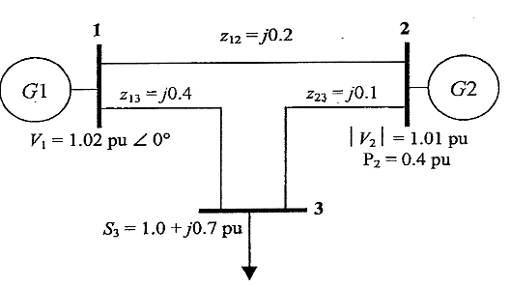 | L5 | CO1 | [5M]
 | b) | Derive bus admittance matrix by singular transformation. | L5 | CO1 | [5M]
12. | a) | Draw the neat sketch speed governing model and derive necessary equations. | L4 | CO2 | [5M]
 | b) | Explain the generator model with a neat sketch. | L5 | CO2 | [5M]
13. | a) | Derive necessary equations for the tie line power load frequency control. | L6 | CO3 | [5M]
 | b) | Analyze the steady state response of single area control. | L4 | CO3 | [5M]
14. | a) | Explain the Gauss Seidel method with a flowchart. | L2 | CO4 | [5M]
 | b) | Create an algorithm for fast decoupled load flow algorithm. List out all the assumptions made in arriving to it. | L6 | CO4 | [5M]
15. | a) | What is swing and derive the swing equation? | L1 | CO5 | [5M]
 | b) | Define steady state stability limit? Derive the necessary condition for the system to be steady state stable. | L2 | CO5 | [5M]
16. | a) | List out and explain Inequality constraints for Economic load dispatch. | L3 | CO6 | [5M]
 | b) | Incremental fuel costs for a power plant consisting of three generating units are I_{C1}=20+0.3P₁,I_{C2}=30+0.4_{P2},I_{C3}=30  Assume that all the 3 units are operating all the time. Minimum and maximum loads on each unit are 50 and 300 MW respectively. If the plant is operating on economic load dispatch to supply the total demand of 700 MW, the power generated by each unit is | L5 | CO6 | [5M]
17. | a) | What is a bus impedance matrix? | L2 | CO1 | [4M]
 | b) | Sketch the schematic of an isolated power system. | L3 | CO2 | [3M]
 | c) | Enumerate the difference between PV buses and PQ buses. | L4 | CO3 | [3M]
18. | a) | Compare Gauss Seidel , Newton Raphson and Decoupled methods for load flow solution. | L6 | CO4 | [4M]
 | b) | Discuss about the methods to improve steady state stability. | L2 | CO5 | [3M]
 | c) | Write short notes on transmission loss coefficients. | L2 | CO6 | [3M]

-- 00 -- 00 –

